Monash University
Simplex CNC Systems
Design Specification
Kun Zhang

22701478

Contents
Abstract 1
1. Introduction 2
2. AC-AC Conversion Methods 2
2.1 Cycloconverter 2
2.2 DC-link Converter 2
2.3 Matrix Converters 3
2.4 Topology Selection 4
3. Electric Protection 4
3.1 Residual Current Devices 4
3.2 Circuit Breakers 4
3.3 Design Requirement 5
4. Filtration 5
4.1 Filtration Options 5
4.2 Output sine-wave filters 6
4.3 AC chokes/Line Reactors 6
4.4 dv/dt filters 6
4.5 Filtration Design Requirements 7
5. Current Sensors 7
5.1 Comparison of the most popular current sensors 7
5.2 Shunt resistor current sensor 7
5.3 Hall Effect Current Sensors 8
5.4 Current-Sensing Transformers 8
5.5 Comparison 8
6. Power Modules 9
7. Simulations 9
7.1 System Overview 9
7.2 Rectification Simulation 10
7.3 Motor Simulation 10
8. Project schedule 11
Reference 12

Abstract
This document details several issues of the project including AC-AC conversion method, electric protection, filtration, current sensors and power modules. A literature review has been written for each issue describing literature relevant to that issue. In addition, design requirements have been listed detailing specific limits and demands of this project.

Simulation methods and results are presented and the schedule of this project has been revised in accord with recent progress.

1. Introduction
The project is to design a current-controlled AC-AC inverter system which can be used for motor control and other applications. The innovation of the inverter involves real-time controlling of the inverter parameters and the control methodology applied. Communication between user’s terminals and the inverter are required to be established. In addition, filters are to be designed and utilised extensively to eliminate possible noises and harmonics.
The project is under the supervision of Dr. Sameh Refaat, director of Simplex CNC, along with Professor Emanuele Viterbo who acts as an administrative supervisor.

2. AC-AC Conversion Methods
In terms of AC-AC conversion, three common methods have been considered; they are cycloconverter, DC-link converter and matrix converter.

2.1 Cycloconverter
Cycloconverters convert an AC waveform to another AC waveform of a lower frequency, synthesizing the output waveform from segments of the AC supply without an intermediate DC link. The output frequency of a three-phase cycloconverter must be less than about one-third to one-half the input frequency. This put a limit on the usage of cycloconverters as their frequency ranges are restricted. [1]
Cycloconverters are used in high power applications driving induction and synchronous motors.

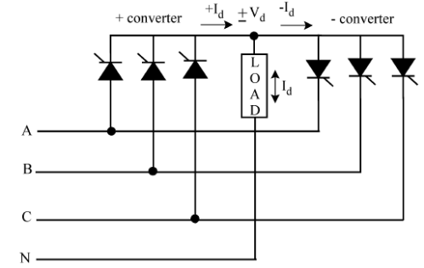

Figure 1. A typical three-to-single half-wave cycloconverter

2.2 DC-link Converter
The DC-link converter consists of a rectifier at the supply side and an inverter (usually a voltage-controlled inverter) at the load side. The DC link transmits the DC voltage to the inverter, provides ride-through capability by storing energy, and provides some isolation from the utility/line
The most common design for an indirect AC – AC converter is the use of diode bridge rectifier at the supply side, as shown in (a). However, this converter topology has high distortion in the input currents, which can cause detrimental effects to other electrical equipment using the same electrical supply.
The topology in (b) utilizes an active PWM rectifier (also known as an active front-end) replacing the diode bridge rectifier. This topology addresses the high distortion problem in (a). However, the use of active devices also increases the losses, converter volume and cost.
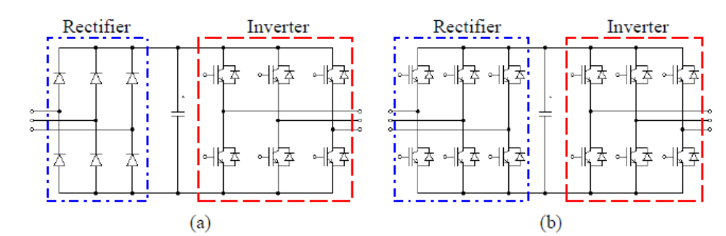

Figure 2. Typical DC-link converter topology with (a) diode rectifier (b) active PWM rectifier

DC-link converters are the most commonly-used topology due to their simple implementations, stabilities and low costs. The main disadvantage of DC-link converters lies in the large storage capacitors which have shorter lifetime and bulky in size

2.3 Matrix Converters
Matrix converters are relatively new technology. The matrix converter consists of 9 bi-directional switches (18 transistors) that allow any output phase to be connected to any input phase. The input phases should never be short-circuited and the output currents should not be interrupted. This implies that one and only one bi-directional switch per output phase must be switched on at any instant. [2]

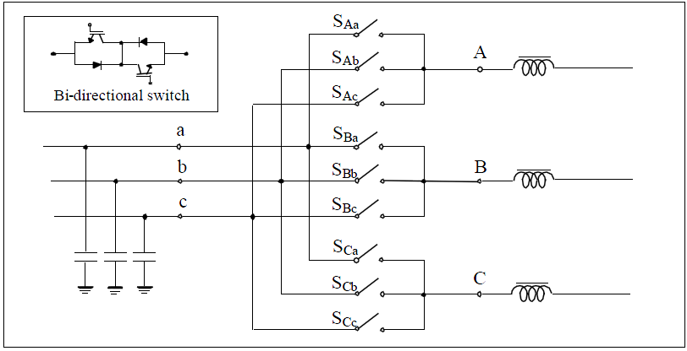

Figure 3. Typical matrix converter topology

Matrix converters are advantageous as they:
- Provide sinusoidal input and output waveforms with minimal higher order harmonics and no subharmonics
- Allow bi-directional energy flow
- Require minimal energy storage (no large capacitors, inductors)
However, the implementation of matrix converters are subjected to input filter and protection issues, which make matrix converters unflavoured commercially. [3]

2.4 Topology Selection
Cycloconverter is overall more efficient than DC-link converter as it does not have an intermediate stage. However, it also has restrictions on the output frequency and its output frequency must be less than the input frequency.
Matrix converter is excellent insofar as it produces fewer harmonic and requires minimal energy storage elements. Yet, in terms of this project, it is not practical for its complexity.
DC-link converter, on the other hand, is less efficient. As a result, it tends to lose a significant amount of power for high-power applications. However, DC-link converters are more feasible due to its low cost and high stability. As a result, the inverter is to be implemented with DC-link topology.

3. Electric Protection
Electric protection is vital in electrical design in that it protects the system and its operators from faults. The aim of a protection scheme is to isolate the components which are under fault from the system. Circuit breakers are the most common devices for electric protection, which are further investigated as follow. In addition, residual current devices are also introduced.

3.1 Residual Current Devices
A residual current device disconnects a circuit whenever it detects that the electric current is not balanced between the energized conductor and the return neutral conductor.
The residual current releases are associated with the circuit-breaker in order to obtain two main functions in a single device:
- Protection against overloads and short-circuits;
- Protection against indirect contacts (presence of voltage on exposed conductive parts due to loss of insulation)

Residual current devices are categorized into three types
- Type AC RCDs which can detect full wave AC residual currents only.
- Type A RCDs which can detect full wave AC and pulsating DC residual currents.
- Type B RCDs which can detect full wave AC, pulsating DC and pure DC residual currents.

3.2 Circuit Breakers
A circuit breaker is a mechanical switching device, capable of making, carrying and breaking currents under normal circuit conditions and also making, carrying for a specified time and breaking currents under specified abnormal circuit conditions such as those of short-circuit. [4]

Circuit breakers are generally classified into following types
- MCB (Miniature Circuit Breaker) — its rated current not more than 100 A. Trip characteristics normally not adjustable
- MCCB (Molded Case Circuit Breaker) — its rated current up to 2500 A. Thermal or thermal-magnetic operation. Trip current may be adjustable in larger ratings.
- Residual-current Circuit Breaker (RCCB) — detects current imbalance, but does not provide over-current protection.
- Residual current breaker with over-current protection (RCBO) — combines the functions of an RCD and an MCB in one package.

3.3 Design Requirement
RCBO breakers are preferred as they provide protection from residual current and over current, both of which may arise in our applications. The parameters required for the RCBO are listed below
Rated Current (all working temperatures) | 10 A
Voltage Rating [peak working voltage] | 311 V
Frequency | 50 Hz
Maximum Interrupting Capacity [current] Icu | 20 A
Overload ratings | I =16A t=3s
Type | A, B
Short circuit Protection | Yes
Residual current protection | Yes
UV protection | Yes
OV protection | Yes

Table 1. Design parameters for RCBO breakers

4. Filtration
The inputs from the mains are usually contaminated by harmonics and noises. Similarly, the outputs from inverter systems often contain harmonics and noises. Consequently, filtrations are required, for both input and output side of the system, to reduce or eliminate unwanted disturbances.

4.1 Filtration Options
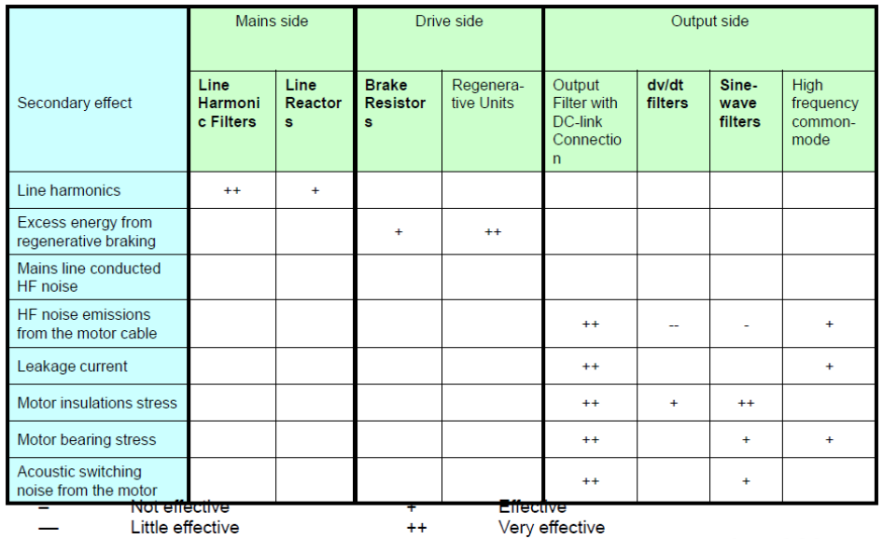
An overview of filtration options are listed below. [5]

Figure 4. A list of filtration options

4.2 Output sine-wave filters
Sine-wave filters provide a sinusoidal phase-to-phase motor voltage filtration. They reduce motor insulation stress and switching acoustic noise from the motor. Bearing currents are also reduced, especially in larger motors.
On the other hand, this type of filter does not operate in common-mode and the leakage currents are not reduced, therefore it does not enable the use of very long motor cables.

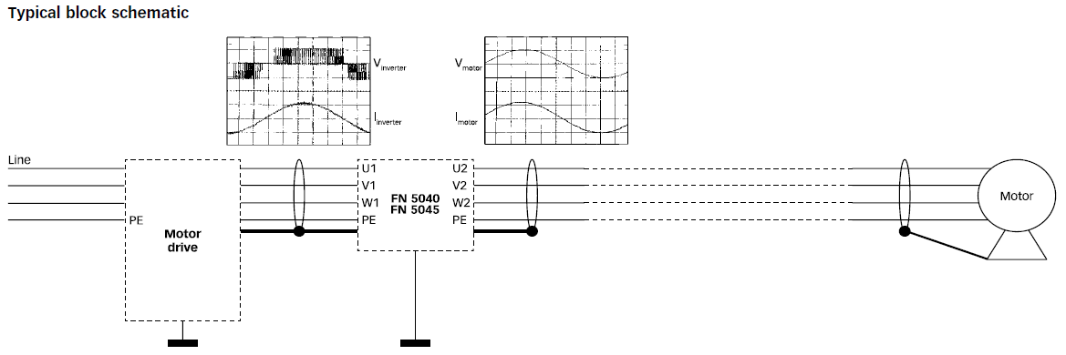

Figure 5. A typical schematic of an output sine-wave filter

4.3 AC chokes/Line Reactors
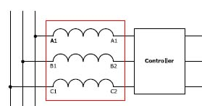
A line reactor is in essence an inductor which reduces harmonics. Other possible functions of line reactors include the reduction of commutation notches and limitation of inrush currents.

Figure 6. A typical schematic of an AC choke

4.4 dv/dt filters
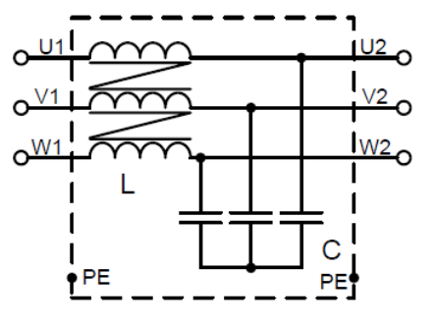
dv/dt filters reduces the values of dv/dt. Compared to sine-wave filters, the dv/dtfilters have a cut-off frequency above the switching frequency. These filters also reduce the motor insulations stress. [5]

Figure 7. A typical schematic of a dv/ds filter

4.5 Filtration Design Requirements
For the purpose of the project, it is proposed that four filters are to be implemented: a sine-wave output filter, an input choke filter and two high-frequency dv/dt filters. The list below presents the basic requirement for the filtration system.
Rated Current (all working temperatures) | 8 – 10A
Application Frequency | 0 - 500 Hz
THD | less than 10%
Application Power Ratings | 2 kW – 20 kW
Table 3. Design parameters for filtration

Some filter models has been purchased. Harmonics are to be measured with these models installed. The measurements can then be used to aid the design of the filtration system.

5. Current Sensors
Current sensors play vital roles in the control of PWM in a way that they sense the output current which are fed back to the controller. The values of the currents are crucial in determining necessary error corrections in vector VFD.

5.1 Comparison of the most popular current sensors
The three most popular current sensors in motor control applications and their main features are listed below:
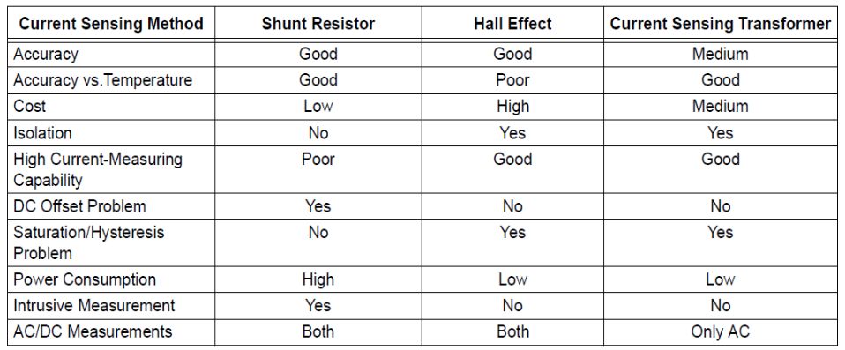

Figure 8. A comparison of current sensors

5.2 Shunt resistor current sensor
The typical schematic of a shunt resistor current sensor is shown below
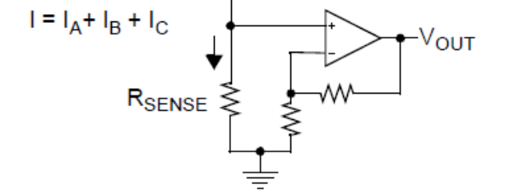

Figure 9. A typical schematic of shunt resistor current sensors

The voltage across Rsense, Vsense is amplified to Vout which is used to calculate the current across Rsense.
A large Rsense will have a larger Vsense, which makes error of the amplifier less significant. However, large Rsense causes two problems: 1) Higher dissipation 2) High EMI noises

5.3 Hall Effect Current Sensors
The Hall Effect is based on the principle that a voltage (VH) is created when current (IC) flows in a direction perpendicular to a magnetic field (B).
The Hall Effect current sensor can be placed on the PCB directly over the current trace that will be monitored. The sensor functions by measuring the magnetic flux that is created by the current flowing through the trace.
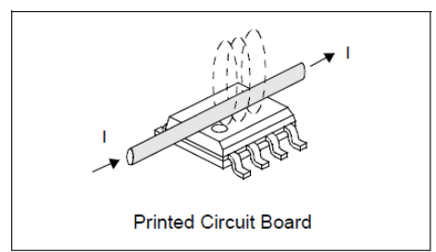

Figure 10. A typical application of Hall Effect Current Sensors

5.4 Current-Sensing Transformers
Current-sensing transformers provide galvanic isolation and can be used in high-current applications. The main disadvantage of current transformers is that an AC input signal is required to prevent the transformer from saturating.
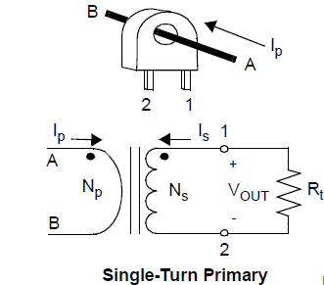
The current sensing transformer is non-intrusive and relatively cheaper than Hall-effect sensors.

Figure 11. A typical of current sensing transformer

5.5 Comparison
Hall Effect sensors seem to be the optimal choice because they do not interfere with the measurand. The main disadvantage of Hall Effect sensor is its higher price, which is not significant as the prices for current sensors are generally low.
Shunt resistor sensors can also be used. The additional noises may be problematic for low-side shunt resistor sensors but not for high-side ones with current mirrors.
Current sensing transforms are used solely for AC applications. Since the output current of the inverter may contain DC component, thus it is not suitable for motor control.

6. Power Modules

A power module is a package six power switching devices which are connected in bridge configurations. With regard of this project, the desired power modules ought to meet following ratings

Parameter | Ratings
Input Voltage | 220
I_{C} (A) | 8 ~ 35 (at all temperatures)
Switching Frequency (kHz) | 20 ~ 30
Switching Time (us) | 33 ~50
Application Power rating (kW) | 1 ~ 30
Configurations | Full bridge
Switching Devices | IGBTs, GTO, FETs
Output frequency (Hz) | 1 ~ 500
Table 8. Requirements for power modules

7. Simulations
Several simulations have been conducted through Simulink including filter simulation, rectification simulation and motor simulation. All simulations were carried on with a sample time of 10 microseconds and using ODE3 as a solver.

7.1 System Overview
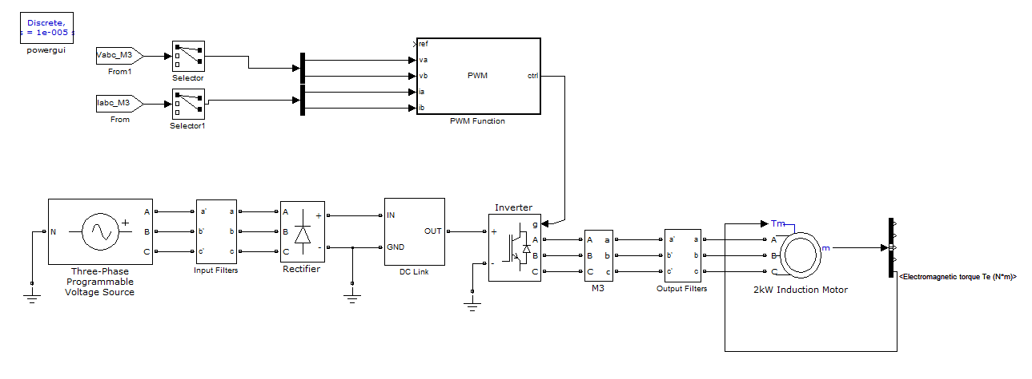
The system has been constructed as shown. The inverter system controls a 2KW induction motor whose torque characteristic is currently unknown. The currents flowing into the inductor motor are used as feedbacks to the PWM function which is to be written in the following semester.

Figure 12. An overview schematic of the inverter system

7.2 Rectification Simulation
The rectification schematic also includes the DC-link section which contains a inductor in parralel with a large storage capacitor. The rectifier is constructed with six diodes with snubber capacitance. The source remains the same as above.

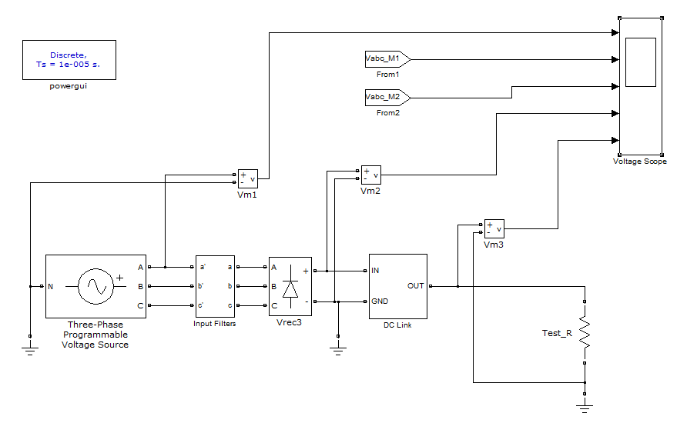

Figure 15. Schematic of the rectification section

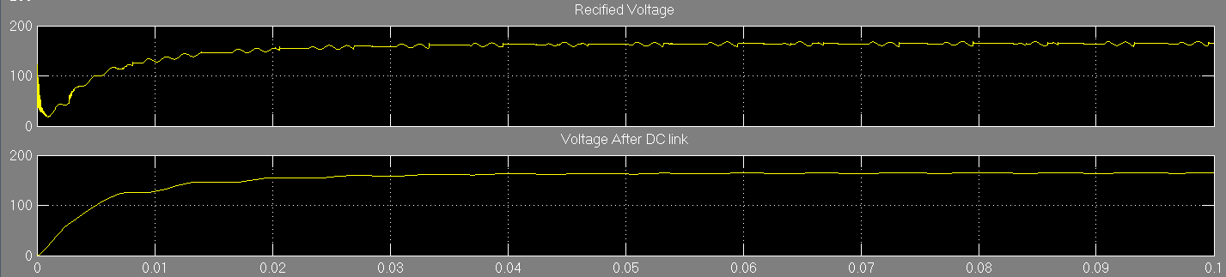

Figure 16. Simulation result of the rectification section

It is observed that the stabilized output of the rectifier contains mainly DC with moderate distortions which are further reduced by DC-link. The voltage after DC link is almost DC with a voltage of 157V

7.3 Motor Simulation
The motor simulation assumes the input of the inverter to be a well-rectified DC, which is modelled by a DC source. The three-phase PWM generator is set to generate a 50Hz modulation signal feeding into the inverter. The torque is fed back to the induction motor with a torque-speed characteristic as shown.

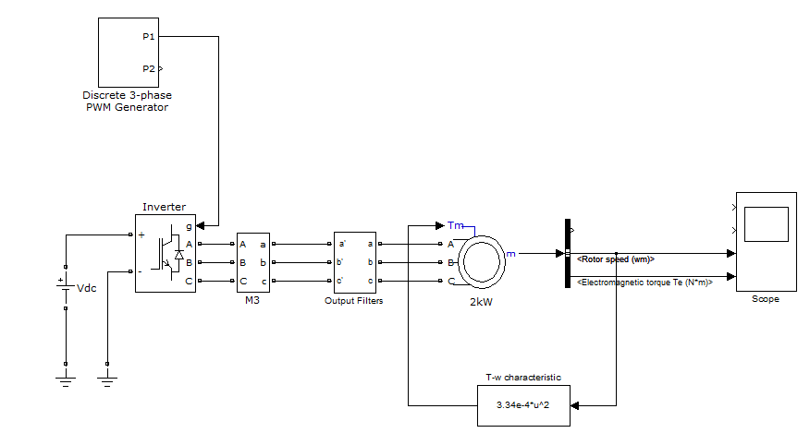

Figure 17. Schematic of 2KW induction motor

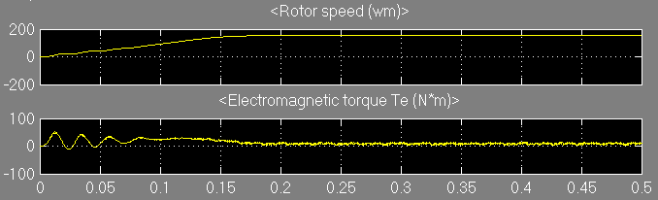

Figure 18. Simulation result of 2KW induction motor

It can be observed that the rotor speed is constant after 0.18s whilst the electromagnetic torque stabilizes after the same period of time.

8. Project schedule

The project starts on week 1 of semester 1 and ends during SWOT VAC of semester 2.

Semester 1 | Week 1-3 | Literature reviews
Semester 1 | Week 4-6 | Literature reviews and simulations
Semester 1 | Week 7-9 | Simulations and harmonics measurements
Semester 1 | Week 10 -12 | Filtration and Protection Testing
Semester 2 | Week 1-3 | Control Design
Semester 2 | Week 4-6 | Programming
Semester 2 | Week 7-9 | Testing
Semester 2 | Week 10 -12 | Compiling final report; Final presentation preparation

Reference
[1] Burak Ozpineci, Leon M. Tolbert, CYCLOCONVERTERS, University of Tennessee-Knoxville
[2] Marco Matteini, Control Techniques for Matrix Converter Adjustalbe Speed Drives, 1998
[3] Luca Zarri, Control of Matrix Converters, University of Bologna, 2007
[4] ABB, Electrical installation handbook - Protection, control and electrical devices, 2010
[5] Danfoss, Secondary effects of variable speed drives, 2011

